Architects Read-Activity
Building Books by Megan Wagner Lloyd

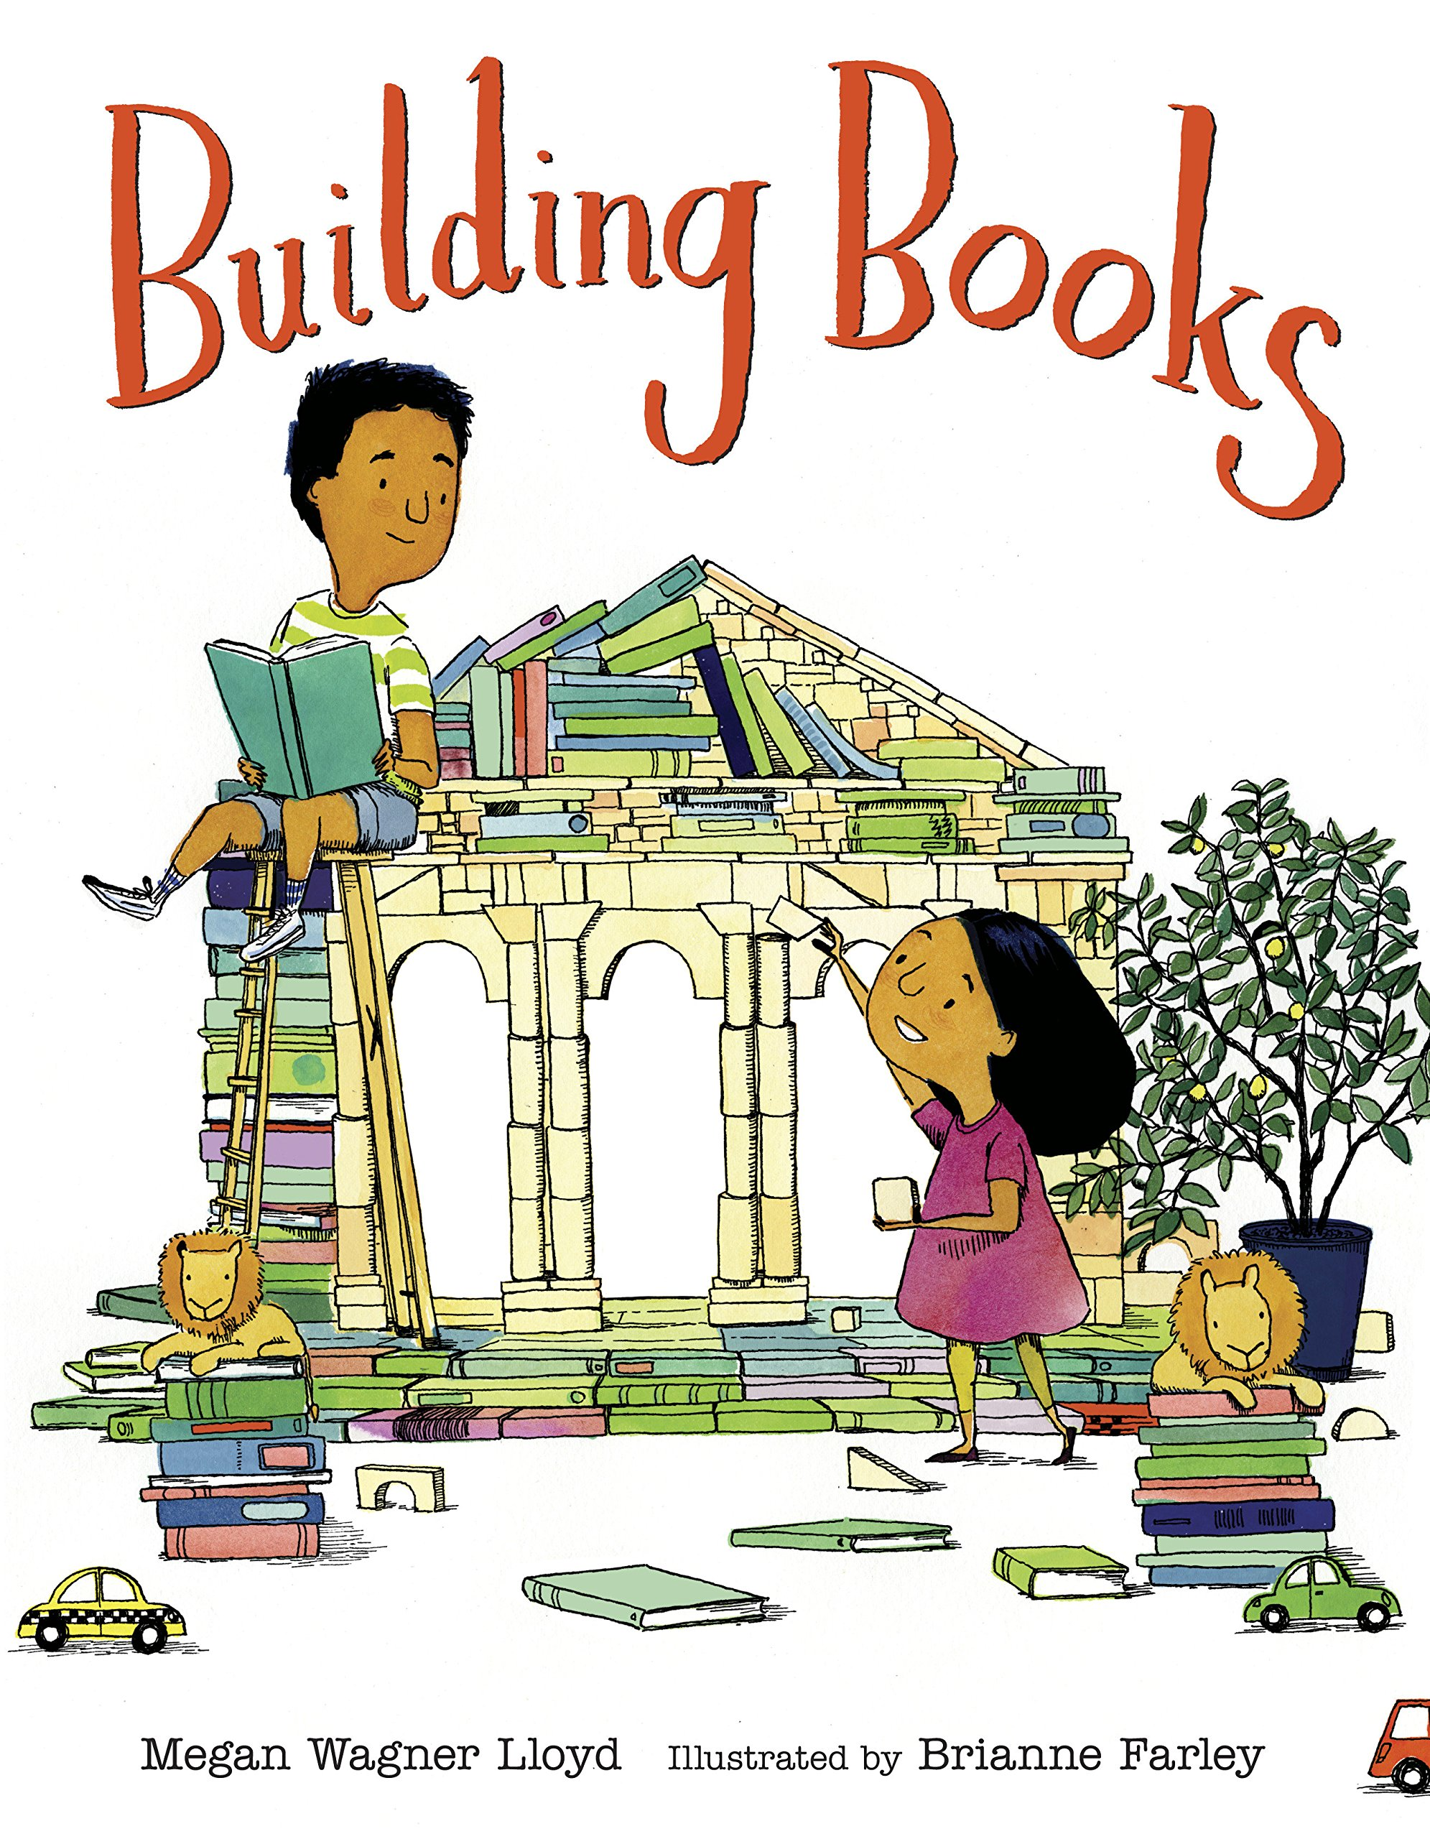
Before you start building with books try this activity. A scavenger hunt!

Find 3 books that are green

Find 2 books that have a building on the cover

Find one book that you haven’t read yet but want to

If you want to build with books, check with an adult to make sure it is safe. Don’t forget to take a picture of your finds and send it to us at @DistrictArchCenter

